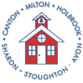 | Old Colony YMCA, 445 Central Street• Stoughton, Massachusetts 02072  (781) 344-1463 • Fax: (781) 344-5299  www.charms-collaborative.org

CHARMS COLLABORATIVE

YOUR JOURNEY TO SUCCESS

FY16 ANNUAL REPORT

Prepared by
Rosalie O’Connell, Executive Director/Program Director
December 2016

TABLE OF CONTENTS

INTRODUCTION 3
GENERAL INFORMATION 4
GOVERNANCE 4
FY15 GENERAL STATISTICS 5
CHARMS ORGANIZATION CHART 6
MISSION AND PURPOSE 7
FOCUS 7
GUIDING BELIEFS 8
GOALS AND OBJECTIVES 9
PROGRESS TOWARD FY16 GOALS 10
COST-EFFECTIVENESS OF PROGRAMS AND SERVICES 11
CHARMS COLLABORATIVE PROGRAMS AND SERVICES 13
PROFESSIONAL DEVELOPMENT OPPORTUNITIES OFFERED IN FY16 17
HIGHLIGHTS FOR FY16 18
CONCLUSION 19

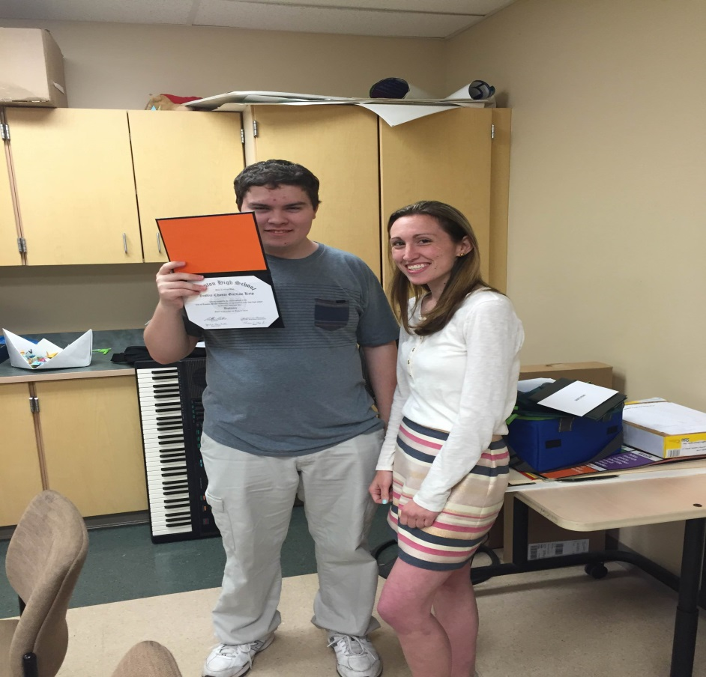
INTRODUCTION

In accordance with Section 43 of the Acts of 2012, Charms Collaborative has prepared the Annual Report and Audit for FY16. On December 7, 2016 the Annual Report and Audit were approved by the Charms Collaborative Board of Directors. The FY16 Annual Report and Audit will be posted on the Charms website (www.charms-collaborative.org) for public review and will be shared with all member school committees.

Charms serviced students from twenty (20) districts in Massachusetts. Expanded collaboration between programs, staff and the community allowed us to enhance service delivery and foster additional community partnerships. With a focus on strengthening our transition planning, staff worked closely with families and students to determine students’ baselines and set individualized goals to best prepare them for their futures. In addition to our five (5) programs, we reviewed and put into action the choice to receive a number of services from any one of the programs that best meet the students’ needs. For example, it was determined that one student would benefit from the services from our alternative learning as well as the vocational/life skills programs in order to reach his/her full potential. With district approval, we were able to create an individualized schedule in order for the student to receive the best of all available services over the course of up to eight (8) years to complete high school requirements.

The Charms Community continued to enhance services for our students throughout the FY16 school year. The focus areas for student supports and staff development were student trauma, mental health and secondary transitioning. One of our overall Charms goals included educating our staff about trauma sensitive classrooms and working with students who have experienced trauma. Over the school year, staff had opportunities to attend workshops, view webinars and be part of the Charms Trauma Committee. We went from only 33% of our staff being comfortable with implementing the strategies to over 90% by the end of the school year. This enabled us to provide services for students who we had previously not been able to support.

At the regularly scheduled meeting of the Charms Board of Directors on June 22, 2016, the Board voted to dissolve the Charms Collaborative Agreement. Charms will remain open and staffed through June 30, 2017. We will continue to provide quality services for our students through June 30, 2017.

Respectfully submitted,

Rosalie O’Connell
Executive Director/Program Director
Charms Collaborative

GENERAL INFORMATION

Administrative Office Location:
Old Colony YMCA
445 Central Street
Stoughton, MA 02072

Office Phone: 781-344-1463
Office Fax: 781-344-5299

Charms Collaborative Twitter @charmscollab

Charms Collaborative Website www.charms-collaborative.org

GOVERNANCE

Board of Directors FY16

Avon Mr. Paul Zinni Superintendent of Schools

Canton Ms. Jennifer Henderson Interim Superintendent of Schools

Holbrook Dr. Patricia Lally Superintendent of Schools

Milton Ms. Mary Gormley Superintendent of Schools
Milton withdrew from Charms as of July 1, 2016.

Sharon Mr. Timothy Farmer Superintendent of Schools

Stoughton Dr. Marguerite Rizzi Superintendent of Schools

Operating Committee FY16

Avon Ms. Christine Godino

Canton Ms. Deborah Bromfield

Holbrook Ms. Cheryl Flynn

Milton Ms. Tracy Grandeau

Sharon Ms. Susan Fisichella

Stoughton Ms. Heather Tucker
Administrative Team FY16

Executive Director/Program Director Rosalie O’Connell

Business Manager Mindy Ryan July 2015 to November 2015
TMS November 2015 to June 2016

Administrative Assistant Christina Farrington
Human Resources/Payroll

Treasurer Marge Foster

FY16 GENERAL STATISTICS

Years in Service 38
Employees 33.1 FTE
Member Districts 6
Districts Served 29
Programs 5
Program Sites 5 Canton (4), Sharon (1)

Staff Demographics

Administration 2.0
Administrative Support 1.0
Teachers 9.0
School Adjustment Counselors 1.6
School Psychologist .5
Nurses 3.0
Speech Therapists 2.0
Physical Therapists .6
Occupational Therapists .6
Teachers of the Visually Impaired 1.8
Educational Assistants 11.0

TOTAL STAFF (FTE) 33.1

CHARMS ORGANIZATION CHART

CHARMS
Board of Directors

Executive Director/Program Director

Professional Staff
Business Manager
Treasurer

Educational Assistants
Administrative Assistant/
Payroll and
Human Resources

MISSION AND PURPOSE

Pursuant to M.G.L. Chapter 40, Section 4E and 603 CMR 50.00, the mission and purpose of the Charms Collaborative is to jointly conduct and create educational programs and services for Member Districts and neighboring school districts when it is determined that such Collaborative programs and services can:

- Provide effective and efficient programs and services on a regional basis.
- Offer cost-effective options.
- Increase educational opportunities for children ages 3-22.
- Improve educational achievement for students with low-incidence disabilities in the least restrictive environment.
- Nurture community-based opportunities in order to expand independent living skills and support transitions.
- Provide professional development opportunities, staff training and consultation.
- Provide contracted services to school districts in order to promote and strengthen cooperative action on behalf of the students.
- Support parents as part of the Educational Team.

FOCUS

Pursuant to M.G.L. Chapter 40, Section 4E and 603 CMR 50.00, the focus areas of the Charms Collaborative are the creation of special education programs and services in the least restrictive environment, comprehensive professional development within local communities of the member and neighboring school districts and the strengthening of family engagement in the educational process.

GUIDING BELIEFS

We believe….

- Each student has intrinsic worth and unique needs

- All students have the ability and need to learn

- All students can learn in appropriately individualized programs

- In providing Professional Development for staff in order to provide current educational strategies to our students.

- All Collaborative programs are an integral part of the Charms community

- Public awareness is the responsibility of the entire Charms community

- In a community partnership to strengthen resources and communication.

- All students have a right to a quality education with high expectations

- All students have the right to learn in a safe and secure environment

- Our diverse Charms communities provide strength for our programs and services

- Collaboration creates a comprehensive continuum of services

- Parents are their children’s most important advocates

GOALS AND OBJECTIVES

Pursuant to M.G.L. Chapter 40, Section 4E and 603 CMR 50.00, the overall goals and objectives of the Charms Collaborative include:

- 1. To provide quality programs to meet the on-going and changing needs of students.
- To administer annual internal evaluations and needs assessments of each program.
- To conduct periodic external reviews/evaluations of current and future programs.
- To provide inclusive, sequential programs with a continuum of educational services and facilities within communities.
- To provide on-going communications with Member and Non-Member Districts regarding collaborative programs in order to support their needs.

- 2. To create and maintain a stable financial infrastructure.
- To consider increasing Charms membership in order to expand programs.
- To pursue grants and other funding to support identified district needs in a cost-effective manner.
- To provide quality, cost-efficient professional development.
- To provide quality, cost-efficient contracted services to districts.

- 3. To provide comprehensive professional development opportunities for both Charms and districts.
- To develop and implement a comprehensive assessment process to meet Collaborative and district professional development needs.
- To provide staff training to meet local, state and federal regulations.
- To provide staff development that sustains and enhances present programming within the Collaborative.

- 4. To support relationships and outreach to staff, parents and community in order to enhance awareness and communications.
- To provide an on-going internal mechanism to increase dialogue and problem solving activities within the Collaborative and community.
- To update the Collaborative website in order to share information and
provide immediate access to information in accordance with the laws.
- Increase community awareness and student involvement in the local communities

PROGRESS FOR FY16 GOALS

- Accomplishments for Goal #1-Quality Programming:
- Internal reviews of programs and services provided in order to meet individualized student needs.
- Independent Review of Charms Multi Skills Programs
- Curriculum updates to meet identified student needs.
- Offering availability of services rather than programs in order to meet individual needs. Students are able to access required services outside of their programs.

- Accomplishments for Goal #2-Financial Infrastructure:
- Continue to assess cost saving measures in order to reinvest savings into the services.
- Business Manual developed in order to track processes.
- Staffing based on service needs of students.
- Increased access to service availability to all Charms students across programs.

- Accomplishments for Goal #3-Professional Development:
- Identified areas of need for Professional Development
- Provided a variety of PD opportunities to meet the needs of all staff.
- Increased opportunities for staff to access PD outside of Charms
- Completed mandated DESE and Health related trainings throughout the school year.
- All staff received on-going training and supports in order to provide Trauma Sensitive Classrooms for all of our students.

- Accomplishments for Goal #4-Outreach
- Utilized Charms Learning Groups
- Community Student and Staff Volunteer Opportunities
- Website, Twitter and Facebook Active Accounts
- Working with Adult Services to Support Transition

COST-EFFECTIVENESS OF PROGRAMS AND SERVICES

Programs

In order to determine cost-effectiveness of the Charms Programs, comparable private day school placements were reviewed. In order to provide a uniform comparison, the daily rate of three private school placements was averaged for each of our three program continuums. Member and non-member savings are based on 180 school days.

Charms Collaborative
Charms Member Non-Member Private Moderate Intensive
Multi Skills Classes $295.38 $357.66 $359.73 $396.26
Elementary Skills Class
Multi Skills I
Multi Skills II
- Member savings over 180 days Mod/$11,582.80 Int/$18,158.20
- Non-member savings over 180 days Mod/$372.30 Int/$6,947.70

Alternative Learning Programs $252.06 $301.20 $313.05
High School
- Member savings over 180 days $10,978.38
- Non-member savings over 180 days $2132.20

Vocational/Life Skills Program $280.68 $327.42 $364.94
- Member savings over 180 days equals- $15,167.20
- Non-member saving over 180 days equals-$6,753.20

Charms Services

Charms programs offer all specialized services (OT, PT, Counseling, TVI, Health and Speech/Language) inclusive to the tuition rate except for home consulting and one to one educational assistant supports. The average student receives between 36 to 72 hours of specialized services in a school year. Students requiring more intensive services may have up to 108 hours of specialized services in a school year. Additional services are billed only for students who are not enrolled at a full time status within Charms Collaborative. The graph bellows indicates the cost saving to member and non-member districts with specialized services included in the tuition.

Charms Collaborative FY16 Specialized Services Rates
Member Rate $79.57
Savings for 36 hours of services- $2,864.52
Savings for 72 hours of service- $5,729.04
Savings for 108 hours of service- $8,593.56
Non-Member Rate $95.23
Savings for 36 hours of services- $3,428.28
Savings for 72 hours of service- $6,856.56
Savings for 108 hours of service- $10.284.84

CHARMS COLLABORATIVE PROGRAMS AND SERVICES

Charms Educational Programs

Elementary Learning Skills: East Elementary School, Sharon

This program is for students ages 10-13 years old with disabilities including atypical development, autism and other pervasive developmental disabilities; developmental communication disorders, including atypical development with related difficulties with motor systems and language development; cognitive, sensory processing, learning and social-emotional needs.
- Opportunities for inclusion with supports
- Individualized Academics
- Behavior Management Plans

Multi Skills 1: Rodman Administration Building, Canton
Satellite Location: Old Colony YMCA, Stoughton

This program is for students ages 13 -15 with multiple disabilities including but not limited to moderate to severe, developmental disabilities, atypical development, autism and other pervasive developmental disabilities, cerebral palsy, vision and hearing impairment, communication disorders and social-emotional challenges.
- Direct instruction is provided for functional academics, behavior/social-emotional, communication, self-care and daily living skills.
- Weekly opportunities for community engagement and pre-vocational training prepare students for adulthood.
- Health Services Available on site.

Multi Skills II: Rodman Administration Building, Canton
Satellite Location: Old Colony YMCA, Stoughton

For students ages 16 to 22 with multiple disabilities including but not limited to moderate to severe, developmental disabilities, atypical development, autism and other pervasive developmental disabilities, cerebral palsy, vision and hearing impairment, communication disorders and social-emotional challenges.
- Direct instruction is provided for functional academics, behavior/social-emotional, communication, self-care, daily living skills and pre-vocational training.
- Weekly opportunities for community engagement and pre-vocational training prepare students for adulthood.
- Opportunities to participate in Vocational/Life Skills Program as appropriate.
- Health Services available on site.
- Family Supports with Transition Planning

High School Alternative Learning Program: Canton High School, Canton

This program is for students age 14-19 that require an academic/ therapeutic setting that allows them to access the general education curriculum with additional support for academics, social, emotional and behavior skills. We serve students who have average to superior intelligence who exhibit one or more of the following disabilities or differences: language-based learning, non-verbal, PDD, communication, anxiety, depression, adjustment disorders and social-emotional fragility.
- Academic classes within small groups or inclusion with supports
- Small group and individualized counseling
- Opportunity to schedule services within our vocational/life skills program

Vocational/Life Skills: Canton High School, Canton
Satellite Location: Old Colony YMCA, Stoughton

This program is for students ages 15-22 who require supports in order to maximize students’ proficiency in all areas of functional life skills in preparation for independent living and potential employment. The staff works with the parents, districts and outside agencies to ensure appropriate transition plans based on individual student needs.
Within this program we offer services to meet each student’s unique profile.
Options include:
- The opportunity for students to participate in inclusion classes as well as be exposed to functional academics, pre-vocational and daily living skills activities. The schedule is designed to meet the individualized needs of each student.
- The opportunity for our older students to participate in “real life” skills and vocational experiences in order to best prepare for independent living and/or gainful employment.
- Opportunity to work towards a high school diploma while participating in the vocational/life skills aspect of the program.

Charms Collaborative Program and Student Data FY16
 | Total Number of Classrooms | Total Number of Students | Member District Students | Non-Member District Students
Multi Skills I: Rodman Building | 1 | 2 | 2 | 0
Elementary Learning Skills: East Elementary School | 1 | 3 | 0 | 3
HS Alternative Learning Program: Canton High School | 2 | 10 | 4 | 6
Vocational/Life Skills: Canton High School | 1 | 10 | 2 | 8
Multi Skills II Programs: Rodman Building | 2 | 11 | 4 | 7
TOTALS | 7 | 36 | 12 | 24

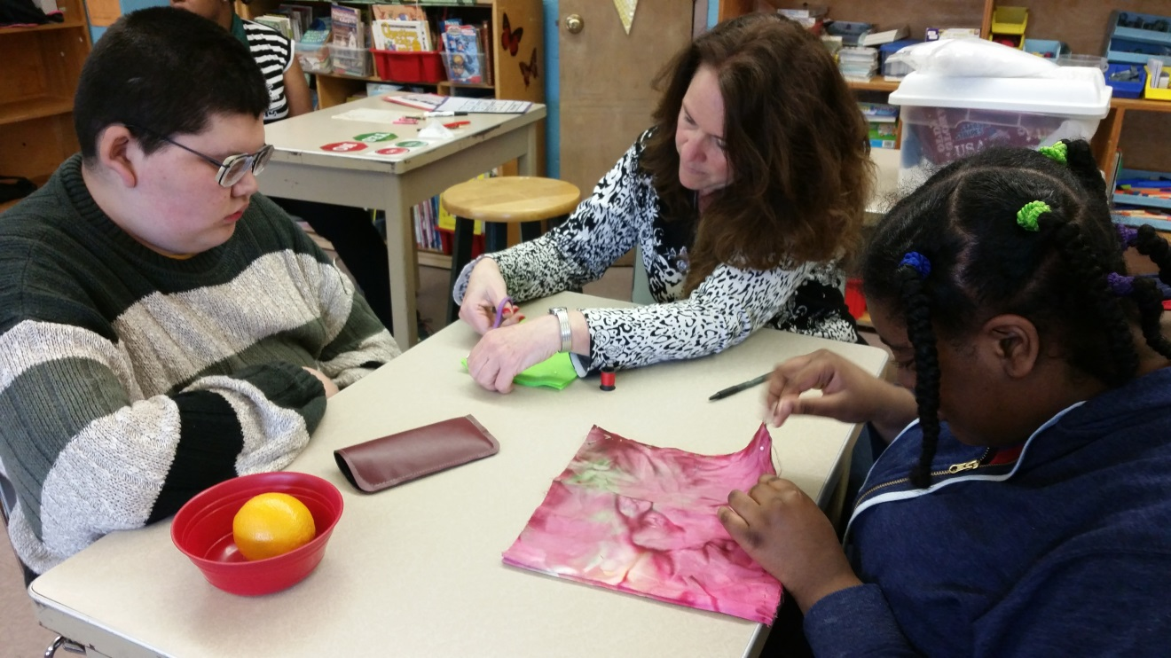

Charms Collaborative Services for Students

- Vision Services

- Physical Therapy Services

- Occupational Therapy Services

- Orientation and Mobility Services

- Vocational Training, Job Coaching, Job Placements

- Transition Planning

- Planning for Post-Secondary Education

- Speech and Language Therapy Services

- Evaluation Services

- Individualized Behavior Plans

- Health Care and Nursing Services including comprehensive Health Care Plans

- Life Skills Support

- Community Partnerships

Charms Collaborative Services for Parents

- Collaboration with outside agencies and health care providers

- Home Consultation (additional fee)

- Support with Assistive Technology

- Transition Planning

Charms Collaborative Services for Professionals and Districts

- Professional Development

- Professional Learning Communities

- Medicaid Billing

PROFESSIONAL DEVELOPMENT OPPORTUNITIES OFFERED IN FY16

- Regulations for Educational Collaboratives
- Confidentiality and Privacy of Educational Records
- Educator Evaluation Workshops
- Non-Violent Crisis Interventions
- Trauma Sensitive Classrooms
- Mental Health First Aid
- IEP Process and Esped Training
- Assistive Technology
- Transition Planning
- Behavior Supports and Implementing Behavior Plans
- Developing and Implementing Functional Behavior Assessments
- Bullying and Cyber-bullying
- Health Related Topics and Trainings

HIGHLIGHTS FOR FY16

- Continued Partnership with Old Colony YMCA in Stoughton

- Student Volunteers

- Classroom for Culinary Arts

- Access to the Y Facilities

- Special Olympics Spring 2016
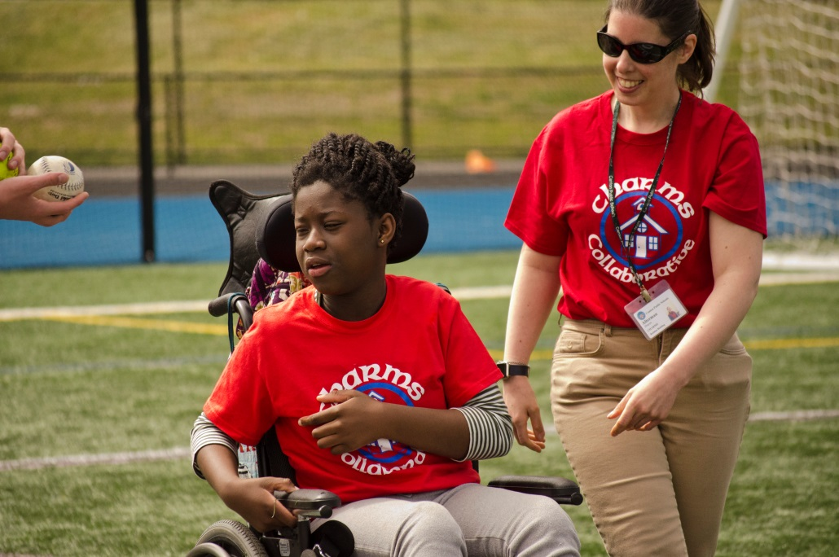

- Student Employment

- Marshalls

- Sports Authority

- Java the Therapy Dog Friday Visits

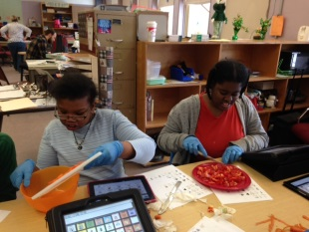

CONCLUSION

In conclusion, Charms Collaborative has continued to develop and provide services that meet the unique needs of the low incidence special education population in our neighboring communities.

